Consequences of land use change and for tropical trees

how habitat availability changes for trees with different habitat preferences?

1. Quantify the total amount of habitat availability change and landscape connectivity/fragmentation for tree species

2. Asses how forest cover changes affected habitat availability according to species habitat preferences and life history strategies

3. Compare past habitat availability changes to the current abundance of species (FIA)

Mini-summary:

Land-use change affects the amount and configuration of habitat available to organisms but species may be differentially affected depending on their habitat preferences.

how habitat availability changes for trees with different habitat preferences?

(ii) how habitat availability changed in form 1950 to 2000 for the most common and wide spread tree species (~200 tree species)
(i) which species of which habitat were most effected by the changes in habitat availability?
(iii) which species showed the highest habitat availability increase?
(iv) were there any species showed habitat losses? what wa was the entity of the habitat loss?

Habitat availability ------ habitat configuration

Word stack
INTRO

Global forest loss
Forest gain/forest regeneration
Active conservation (trees planting) + “passive conservation” agriculture abandonment
Regeneration opportunities/potential “tropical forest can recover 80% species diversity after 20 years?
Canopy cover gain does not mean forest regeneration
Habitat bottle necks? What are the actual possibilities of recovery?
- Specie composition
- Species abundance
- Genetic diversity
Puerto Rico
Strong land use shift
Opportunity to study how tropical forest and TREE Aspecies react to habitat bottlenecks
The context of Puerto Rico
Land use change agricultural abandonment natural forest regeneration
Forest cover maps 1950 - 2000
No species extinction even though strong habitat loss and gain
- High resilience (high dispersal capability) due to small spatial scale
- Dramatic Topography as protecting factor
- Specie’s are experiencing extinctions debt
Environmental heterogeneity, habitat types forest types

Model Islans/reference system to asses tropical forest recovery after habitat bottle necks!
the specific questions we are trying to answer to undestand Puerto Rico’s forest resilience to past habitat bottle necks are:

(ii) how habitat availability changed in form 1950 to 2000 for the most common and wide spread tree species (~200 tree species)
(i) which species of which habitat were most effected by the changes in habitat availability?
(iii) which species showed the highest habitat availability increase?
(iv) were there any species showed habitat losses? what wa was the entity of the habitat loss?

METHODS
Study system: Puerto Rico
- Ecology, life zones, habitat types, forest types
- History of land use
Data
Plant Occurrence records
Life zone map
Climatic variables
Forest cover maps
SDMs (as many species as we have data for, at leas 25 occurrence record per specie to model)
Analysis
Forest cover change in each of the life zones
Habitat change for each tree species
Absolute habitat change
Relative habitat change
Habitat change for each tree species
Habitat change the species of the different life zones
Results
Forest cover change
Habitat change for each tree species
Most species had low to medium increase in their habitat availability
The life zone the was the most affected
Some species showed habitat losses

DISCUSSION
(1) Why most species showed low to medium increases in their habitat availability?
(2) Why some species showed habitat losses
(3) Environmental heterogeneity, habitat types forest types, different forest types might respond differently?
(4) No species extinction, even though strong habitat loss and gain
- High resilience (high dispersal capability) due to small spatial scale
- Dramatic Topography as protecting factor
- Specie’s are experiencing extinctions debt

Land use change is common phenomenon in the tropics, this is often connected with the expansion or contraction of agricultural lands affecting forest cover and natural forest regeneration.

Using a case study form the Caribbean Island of Puerto we analyze how tropical trees respond to habitat bottlenecks looking and how habitat availability changed over time for threes with different ecological preferences and life history strategies.

Outline Paper one

Introduction

- Land use change in the tropics
  - Global loss of tropical forest
  - cases of Forest gain, secondary forest, are these able to recover form deforestation events
- The case study of Puerto Rico
  - abandonment of agricultural lands
  - strong habitat bottleneck forest cover (6% 60%)
  - no recorded species exitrons
- Main aims and research questions

Methods
- The study system
  - Ecology, climate and lifezones
  - Hystory of land use change
- Data
  - Plant Occurrences
  - Life zones map
  - Climatic variables
  - Forest cover maps
- SDMs
- Analysis
  - Forest cover change in each of the life zones
  - Absolute habitat change
  - Relative habitat change
Results
- Forest cover change by life zone
- Absolut Habitat change for each of the three species
- Relative habitat change

Discussion
- Environmental heterogeneity, habitat types forest types, different forest types might respond differently?
- Why most species showed low to medium increases in their habitat availability?
- Why some species showed habitat losses No species extinction, even though strong habitat loss and gain
- High resilience (high dispersal capability) due to small spatial scale
- Dramatic Topography as protecting factor
- Specie’s are experiencing extinctions debt

Fig 1. Forest cover change on Puerto Rico from 1951 to 2000. Elaborated form Helmer et. al 2019

Fig 2. Forest cover change in each of the life zones from 1950 to 2000
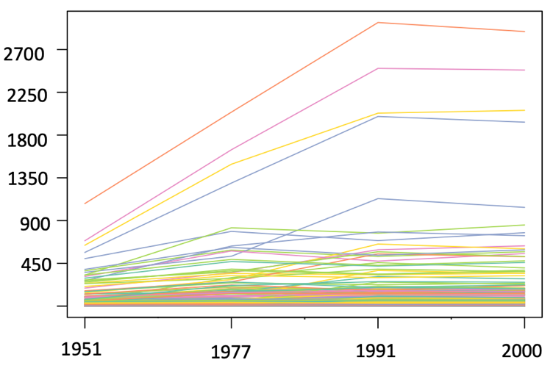
Area of habitat change (km²)

Years

Fig 3. Absolute habitat change in Km² from 1950 to 2000 for 250 native tree species

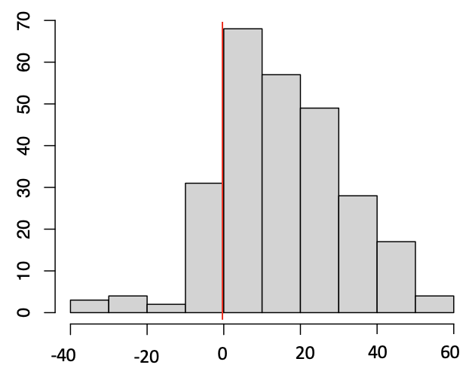

Frequency

% of habitat change

Fig 4. Relative habitat change, % of habitat change for 250 native tree species from 1950 to 2000

-40
20
0
-20
40

% of habitat change

Life zones

Fig 5. Proportion of habitat change for the tree species of each lifezone, Subtropical dry forest (df-S), Subtropical moist forest (mf-S), subtropical rain forest (rf-S), Lower montane wet forest (wf-LM), subtropical wet forest (wf-S); form 1950 to 2000.

